

|  |
| --- |
| CPI ANALYSIS |
|  |
|  |

CPI INSIGHS:

CPI (Consumer Price Index) is an economic indicator that measures the average change in prices paid by consumers for goods and services over time. It is used to track inflation and the cost of living.

Key Points about CPI:

* It reflects price changes for everyday expenses like food, housing, transportation, healthcare, and clothing.
* Governments and central banks use it to adjust policies, wages, and benefits.
* It is calculated by taking a weighted average of selected items in a market basket.

“The analysis taken on bases of 2012 as base index”

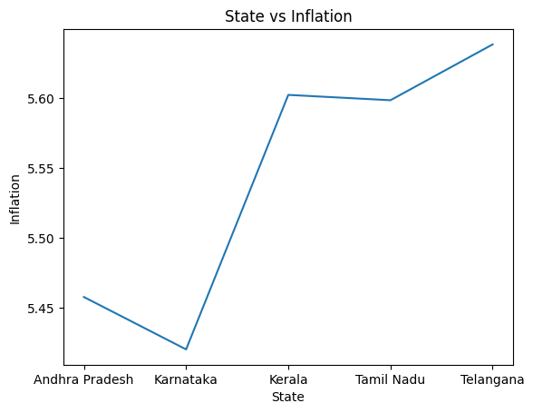

Here we can observe the state vs inflation graph. The graph shows that the inflation is high in Telangana. In Karnataka can see low inflation when compared to other states. The Kerala and Tamil Nadu have all most same Inflation. The Andhra Pradesh has higher inflation compared to Kerala. There could be various reason. The Inflation increases the cost of living is also increases, necessary measures need to take to reduce inflation rate in this state. The policy which is used in Karnataka where the inflation rate is low can be implemented in other states also. The inflation rate is in range of 5.4 to 5.6. May be the difference between the states is minimal. We should make sure that the inflation rate is always be low which is good for nation economy.

There are mainly three sectors are: Rural, Urban, Combined(which is a combination of both rural, urban).

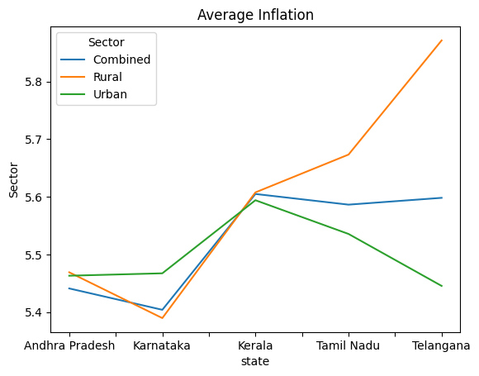

Here again we observe the inflation on states in respective sectors. In this graph the inflation is high in Telangana which is already observed in above graph. In Telangana we observe that rural area is facing high inflation compared to urban and combined area. In can also see that the urban sector is having very low inflation it means their cost of living is very low.

If the rural is also well developed then the Telangana well have a robust economy compared to all. In Karnataka which is reverse to Telangana state,

That is the urban area is having high inflation compared to remaining sectors. The rural area is having less inflation. Combined sector is having a moderate inflation on all states. We can say that, much focus on urban and rural area of states to reduce inflation rate.

Index value is also a important parameter of customer index.

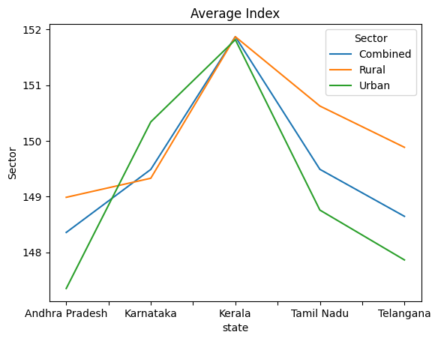

Index value says about the rise in prices of goods which are consumed by the customer. In Kerala we can index values of good high in every sector. Low index prices are observed in Andhra Pradesh. In remaining states having moderate index values. High index value is a sign of disturbance in economy. The necessary action has to be taken to reduce the index value of prices on goods and services. If the higher index value badly effects the economy. The inflation will also rise.

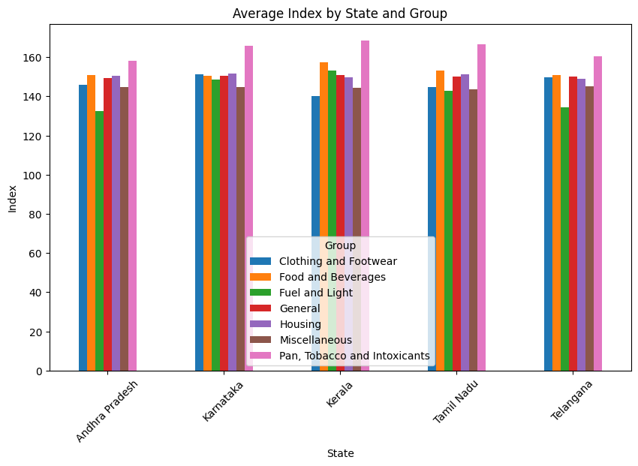

The major goods and services are clothing and footwear, food and beverages, fuel and light, general, housing, miscellaneous, pan, tobacco and Intoxicants.

We can observe that the pan, tobacco and Intoxicants index value is high in all states. Food and beverages, housing are very basic necessary of customer, the index values high will affect them very badly. One thing is observed is fuel and light values low in very state which is relief to people.

Clothing and footwear are moderate in all states. The major sources of good which is basic necessaries of person is available in very high cost is not good thing. Due to this the poor people will affect very badly. The index increases the economy is in struggle. To get rid of it is necessary for the wellbeing of the nation. The index values could rise due to lack of production, the unexpected climate condition which will affect the agricultural products. The government should stop export and release the buffer stock. It may reduce the prices of index to some extent. But it is a short-term solution.

We need to work on exploring long-term solution.

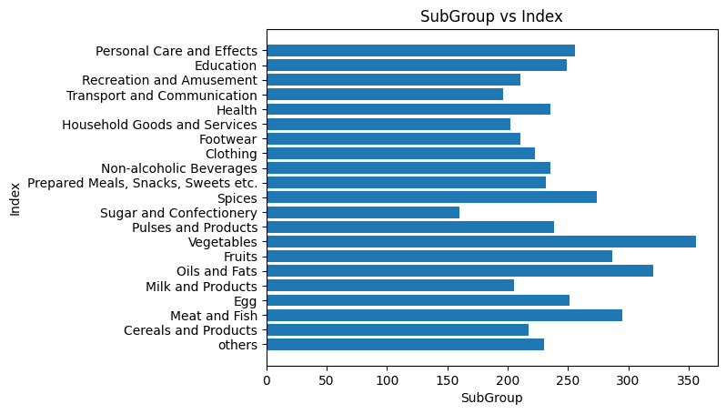

These graph gives an in-detail information of what kind of goods are having a high index value. Here vegetables are having high index values. Spices, meet and fish, oil and fat are having relatively low index value compare to vegetable. The food is essential for survival of human being. Availability of the food resources will become difficult. There is a chance of increase malnutrition in people due to poor access to the food resources, since the prices are increases. The government should provide subsides to food resources so that poor people can get them in less prices. The remaining goods are having moderate index value. The government should make policy to reduce the index values of goods and services.

“The main indicator of the economy are index value and inflation”

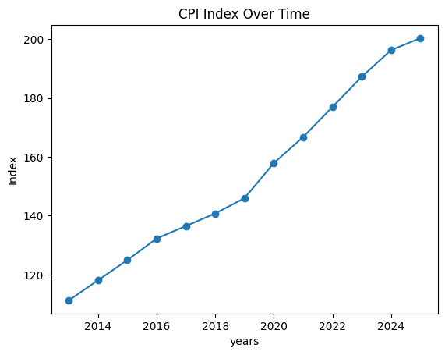

In this we can clearly understand the index value is steadily increase from year by year. We say the economy is not stable.

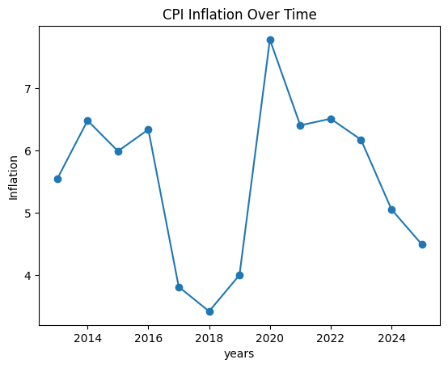

The inflation fluctuates over the years this indicates the economy is not stable.

With this I conclude that the index value and inflation are two pillars of economy. The economy stability decides the development of nation.

Necessary action and measures to be taken to reduce index value and inflation. I hope this analysis will help.